1.Compress a file by compress, gzip, zip commands and decompress it again. State the differences between compress and gzip commands.

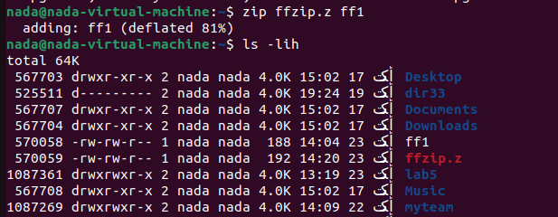

\*gzip compress the file smaller than compress >>>> but compress run faster

2. What is the command used to view the content of a compressed file.

3. Backup /etc directory using tar utility.

4. Starting from your home directory, find all files that were modified in the last two day.

5. Starting from /etc, find files owned by root user.

6. Find all directories in your home directory.

7. Write a command to search for all files on the system that, its name is “.profile”.

8. Identify the file types of the following: /etc/passwd, /dev/pts/0, /etc, /dev/sda





9. List the inode numbers of /, /etc, /etc/hosts.

 -id

10. Copy /etc/passwd to your home directory, use the commands diff and cmp,

and Edit in the file you copied, and then use these commands again, and check the output.

11. Create a symbolic link of /etc/passwd in /boot.



12. Create a hard link of /etc/passwd in /boot. Could you? Why?

